
DATE: 16.12.2020

MUSIC PROPOSAL

Lori & Yossi’s Wedding | 19 December 2021
Venue: Cavalli Estate, Stellenbosch



Prepared for:
Anne Mann
Anne Mann Celebrates
anne@annemann.co.za

bookings@tonesofnote.com

www.tonesofnote.com

+27 72 510 4859

ABOUT US

For 20 years, Tones of Note has been satisfying clients with a love for music - clients who recognise the essential part music plays in creating an extraordinary experience. The agency of choice for some of the world’s finest event producers, from Colin Cowie to Anne Mann, we offer an exceptional service, going to great lengths to translate a client’s dream into musical reality.
We love what we do. This translates into the incredible care and attention to detail we give each event. Working with the finest local and international performers, our bands and musicians perform with passion and energy every time they take the stage. Guaranteeing flawless execution regardless of style and genre, we offer incredible versatility and professionalism for all occasions, settings and tastes.
It is our greatest joy to work with clients in curating and producing a distinctive entertainment offering. Making music while taking care of business, you can be assured of a structured process which guides you in your musical decision making, bringing your personal taste to the

fore and ensuring your event reflects who you are.

Please click on the image above to go through to the video reference.
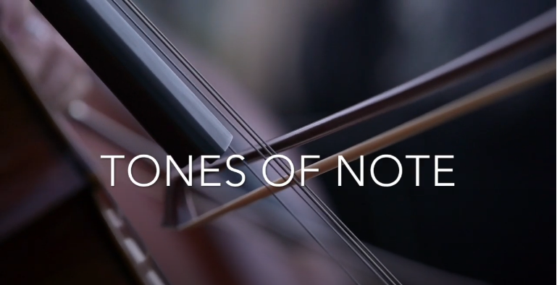

www.tonesofnote.com

+27 72 510 4859

bookings@tonesofnote.com

Your wedding is an intimate reflection of you and as such requires musical and creative attention. To authentically convey that feeling to the guests sharing in this momentous day, your musical input is invaluable.
Over the next year, we’ll be working with you on your wedding soundtrack. Building on our experience of what works and what doesn’t, we’ll guide in the repertoire selection process from closing guest arrivals to closing song.
Most of the suggestion acts below are open to learning new repertoire, so if you’ve got something specific in mind, let us know. While we’ll try out best to accommodate your vision, we’ll also be honest when we feel something won’t work musically or is not possible.

PROJECT BRIEF

Building on the emotion created at the Chuppah, this period allows guests to catch up with friends and family while taking in their surroundings. The music during this time should animate/enliven those conversations not interfere or compete with them.
A DJ is a good alternative to a band for pre-drinks. Musically speaking, DJs have a broader range of styles and songs to choose from, allowing them to take the music where the guests want it to go. Ultimately this set must be upbeat, featuring songs that appeal to the majority of your guests while also representing your musical preferences.
This is achieved by playing a mix of classics from soul, jazz, reggae and current popular music. Added to the DJ we suggest includinglive instruments creating depth and setting the tone for the rest of the event.

PRE-DRINKS

ARTIST SELECTION
Rus Nerwich (DJ)
Hailing from Cape Town, saxophonist, composer, producer and DJ Rus Nerwich has established himself as one of South Africa’s most creative and prolific recording and performing artists. Crossing genres from jazz and funk to world music and neo-soul, Rus' style is diverse, engaging and constantly evolving.

Continued on next page.

www.tonesofnote.com

+27 72 510 4859

bookings@tonesofnote.com

Rus Nerwich (DJ) –continued.

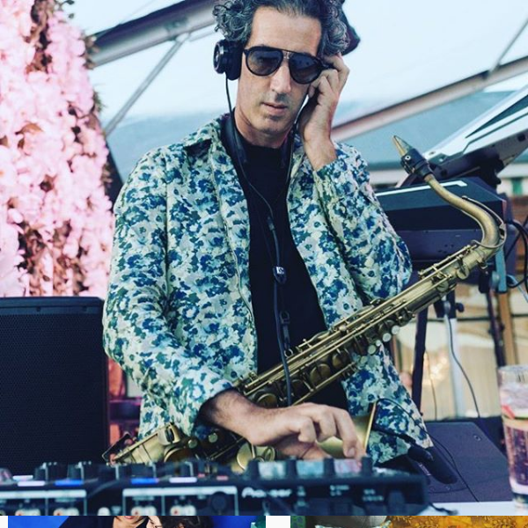
Please click on the image for the video reference.

Lee Thomson | Trumpet
Lee has played in South Africa’s top rock bands such as Springbok Nude Girls, Golliwog and Hog Hoggidy Hog. Other projects that he plays with regularly are Closet Snare, Mix n Blend, Valve State, Gavin Minter Septet, Dave Ledbetter and the Clearing as well as the Mike Campbell Big Band and The Jonny Cooper Orchestra. He has also performed with the Violent Femmes. He is also a prolific session musician, having done work for Freshlyground, Valiant Swart, Amanda Tiffin, Goldfish and many more.
Lee played in the National Youth Jazz band has a Jazz Degree from UCT. He is currently touring around the world with his various projects. He has done gigs in Germany, Austria, Switzerland, London, India,Spain, Holland, Slovenia, Mexico, Reunion Island and South Africa.
Lee has released with We Set Sail, Closet Snare, Restless Natives, Hog Hoggidy Hog, Rumswinger and Mix ‘n Blend.

www.tonesofnote.com

bookings@tonesofnote.com

+27 72 510 4859

Lee Thomson | Trumpet (Continued.)
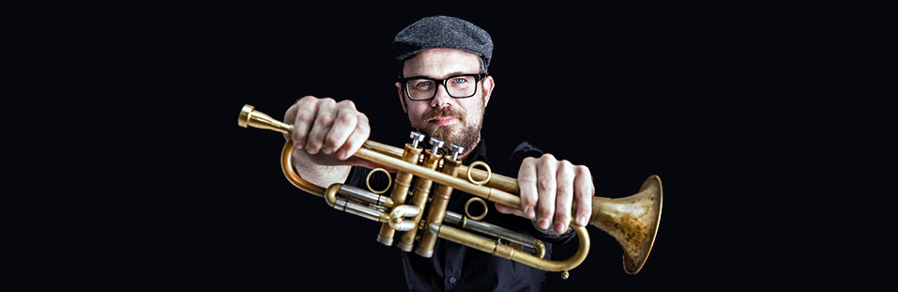
Please click on the image for the video reference
Percussion: John Hassan
The minister of percussion, which John Hassan has been referred to, is a highly acclaimed artist. He has recorded more than 100 albums in addition to his own.

He has worked with Miriam Makeba, Regina Carter, Kyle Anderson, Toto, Hugh Masekela, Stimela, Chucho Valdez, Andy Narell, Jonathan Butler, Marion Meadows, Jimmy Dludlu, Judith Sephuma, Johnny Clegg, Caepha Semenya, Letta Mbulu, Moses Molelekwa, Manu Dibango, Simphiwe Dana.

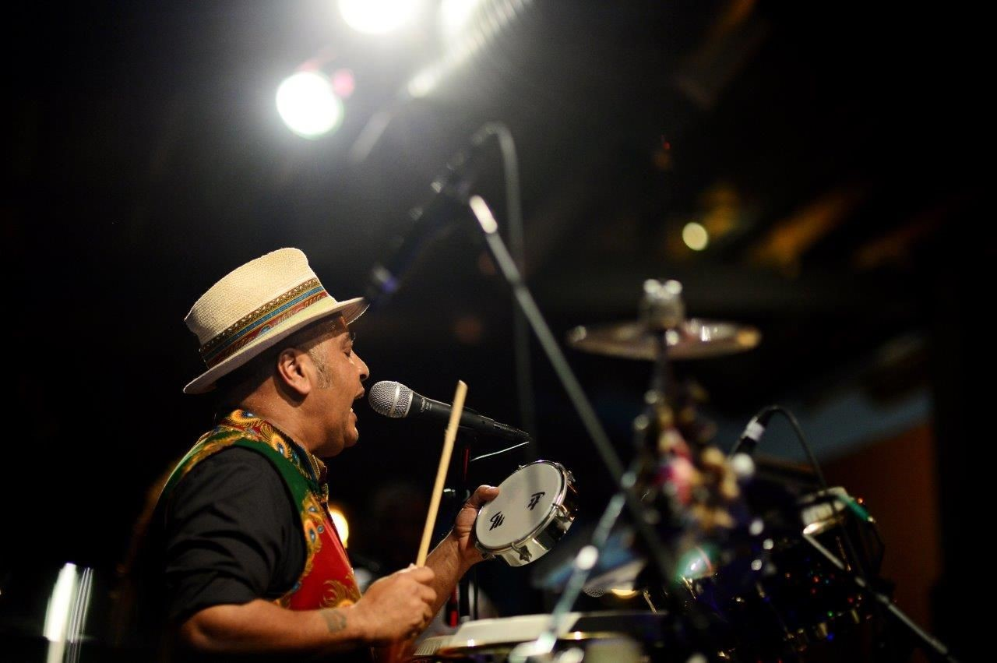

DINNER & DANCE
www.tonesofnote.com

bookings@tonesofnote.com

+27 72 510 4859

Over dinner, given the space and the acoustics, we suggest having a DJ perform during this section, facilitating flow around speeches.
Then directly following your first dance, the band featuring Nathan Ambach on vocals, accompanied by saxophone, keys or guitar, bass and drums to perform high-energy dance set.
Touring and performing together for the last 6 years, Rus Nerwich and Nathan Ambach (N8N) have developed an electric onstage chemistry, offering clients an all-inclusive musical solution.
Both Nathan and Rus bring together 20 years of musical and performance experience. From world-class live performances of quintessential classics covering soul, funk, blues, pop and jazz to a dance till you can’t dance no more DJ set, you are guaranteed one of the greatest parties of your life!

I’ve included a female vocalist in the budget but we can remove this if needs be. We also have options here to choose from, which we can discuss at a later stage.

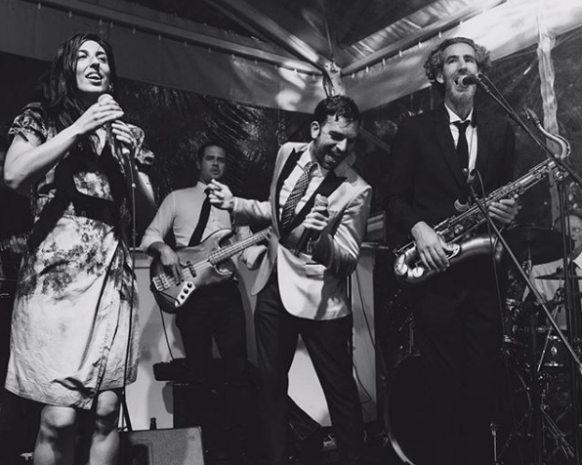
Please click on the image for the video reference.

https://www.youtube.com/watch?v=AOY6eff1cj8

In 2006, in his hometown of Antwerp, Nathan launched the nightlife series: The Love Below as ‘Your Monthly Rendezvous with Soul’, where he is still the resident DJ + promoter of funky music worldwide!
He’s DJ’d alongside Mark Ronson at the WMC in Miami and played at the Love Below with DJ Jazzy Jeff (The Fresh Prince), DJ Premier, DJ Maseo (De La Soul), and DJ Rashida – the official tour DJ of Prince and Bruno Mars and DJ'd sets in clubs and events around Europe, America, Asia, Africa and the Middle East.
His Spotify playlists and online mixtapes represent his funky style, championing soulful music with great grooves and party hooks. For over 20 years, N8N has been rocking the business from BBQs to Bar-Mitzvahs!
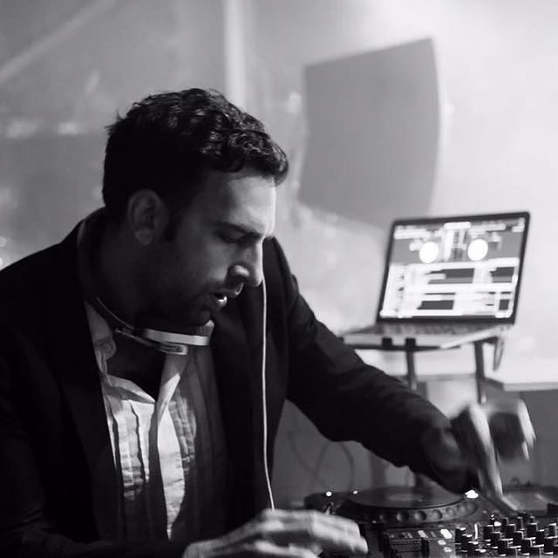
Please click on the image for the video reference.
N8N - DJ + Live Accompaniment
N8N - Mixcloud

PARTY
www.tonesofnote.com

+27 72 510 4859

bookings@tonesofnote.com

